**SUBQUERIES IN SQL**

Whenever there is an indirect condition, generally we go for the subqueries.

Whenever we write a subquery, we may sure be sure that at least one common column exists between tables.

There are 2 types of sub-queries. 1) Single-Row Subqueries

2) Multi-Row Subqueries.

**SINGLE-ROW SUBQUERIES:**

It returns a single output, hence we use a relational operators.

**MULTI-ROW SUBQUERIES:**

It returns multiple outputs, hence we use (SPECIAL OPERATOR) **IN**.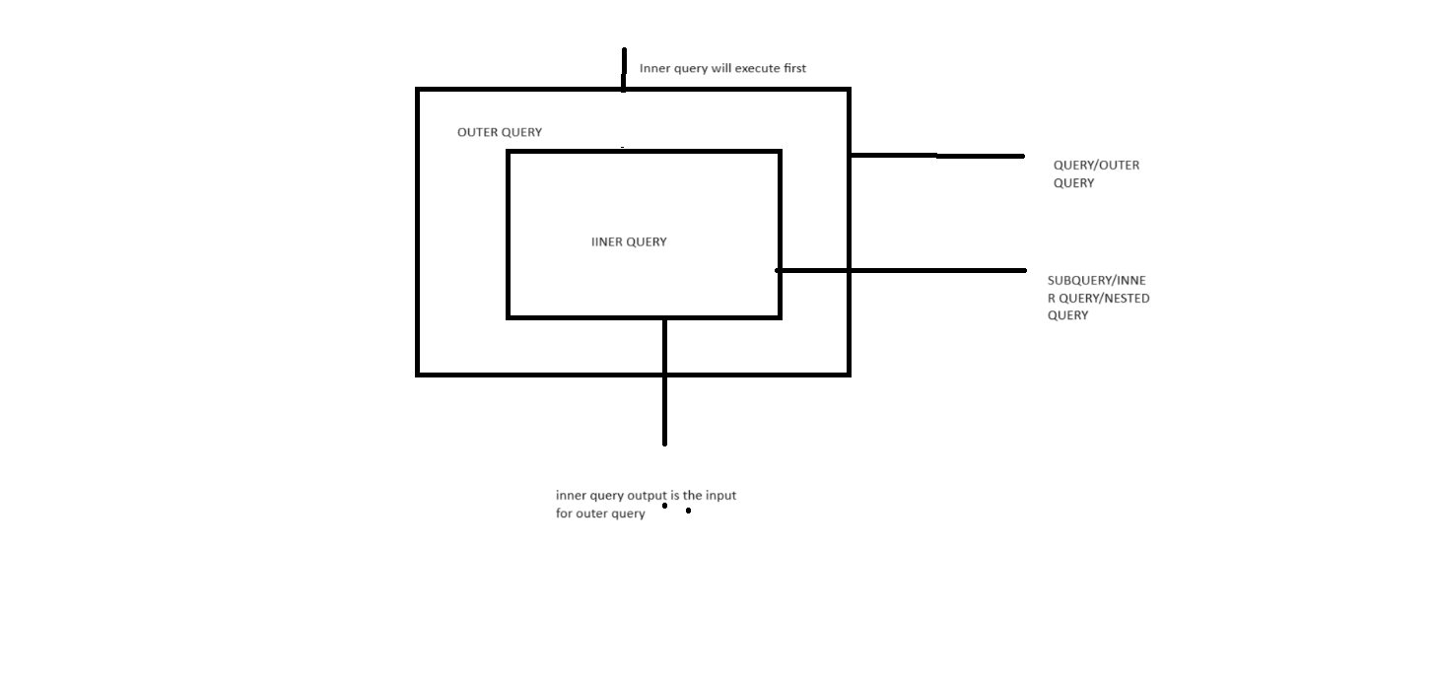

1.Write a query to Display whose deptno is similar to allen.

**select * FROM EMP WHERE DEPTNO=(SELECT DEPTNO FROM EMP WHERE ENAME='ALLEN');**

Output:

+-------+--------+--------+----------+------+------------+--------+------+

| EMPNO | DEPTNO | ENAME | JOB | MGR | HIREDATE | SALARY | COMM |

+-------+--------+--------+----------+------+------------+--------+------+

| 7499 | 30 | ALLEN | SALESMAN | 7698 | 1920-02-20 | 1600 | 300 |

| 7521 | 30 | WARD | SALESMAN | 7698 | 1981-02-22 | 1250 | 500 |

| 7654 | 30 | MARTIN | SALESMAN | 7698 | 1981-09-28 | 1250 | 1400 |

| 7698 | 30 | BLAKE | MANAGER | 7839 | 1981-05-01 | 2850 | NULL |

| 7844 | 30 | TURNER | SALESMAN | 7698 | 1981-07-08 | 1500 | 0 |

| 7900 | 30 | JAMES | CLERK | 7698 | 1981-12-03 | 950 | NULL |

+-------+--------+--------+----------+------+------------+--------+------+

2. Write a query to Display all the employee details whose designation is similar to an employe whose employee no is 7900

**SELECT * FROM EMP WHERE JOB=(SELECT JOB FROM EMP WHERE EMPNO=7900);**

Output:

+-------+--------+--------+-------+------+------------+--------+------+

| EMPNO | DEPTNO | ENAME | JOB | MGR | HIREDATE | SALARY | COMM |

+-------+--------+--------+-------+------+------------+--------+------+

| 7369 | 20 | SMITH | CLERK | 7902 | 1980-12-17 | 800 | NULL |

| 7876 | 20 | ADAMS | CLERK | 7788 | 1987-05-23 | 1100 | NULL |

| 7900 | 30 | JAMES | CLERK | 7698 | 1981-12-03 | 950 | NULL |

| 7934 | 10 | MILLER | CLERK | 7782 | 1982-01-23 | 1300 | NULL |

+-------+--------+--------+-------+------+------------+--------+------+

3. Write a query to Display whose salary is more than average salary of 10th Dept.

**SELECT * FROM EMP WHERE SALARY>(SELECT AVG(SALARY) FROM EMP WHERE DEPTNO=10);**

Output:

+-------+--------+-------+-----------+------+------------+--------+------+

| EMPNO | DEPTNO | ENAME | JOB | MGR | HIREDATE | SALARY | COMM |

+-------+--------+-------+-----------+------+------------+--------+------+

| 7566 | 20 | JONES | MANAGER | 7839 | 1981-04-02 | 2975 | NULL |

| 7788 | 20 | SCOTT | ANALYST | 7566 | 1987-04-19 | 3000 | NULL |

| 7839 | 10 | KING | PRESIDENT | NULL | 1981-11-17 | 5000 | NULL |

| 7902 | 20 | FORD | ANALYST | 7566 | 1981-12-03 | 3000 | NULL |

+-------+--------+-------+-----------+------+------------+--------+------+

4. Write a query to Display all the employe detauls whose designation is similar to blake and salary is more than martin.

**SELECT * FROM EMP WHERE SALARY>(SELECT SALARY FROM EMP WHERE ENAME='MARTIN')**

**AND JOB=(SELECT JOB FROM EMP WHERE ENAME='BLAKE');**

Output:

+-------+--------+-------+---------+------+------------+--------+------+

| EMPNO | DEPTNO | ENAME | JOB | MGR | HIREDATE | SALARY | COMM |

+-------+--------+-------+---------+------+------------+--------+------+

| 7566 | 20 | JONES | MANAGER | 7839 | 1981-04-02 | 2975 | NULL |

| 7698 | 30 | BLAKE | MANAGER | 7839 | 1981-05-01 | 2850 | NULL |

| 7782 | 10 | CLARK | MANAGER | 7839 | 1980-12-17 | 2450 | NULL |

+-------+--------+-------+---------+------+------------+--------+------+

5. Write a query to Display the Work location of TURNER.

**SELECT LOCATION FROM DEPT WHERE DEPTNO=(SELECT DEPTNO FROM EMP WHERE ENAME='TURNER');**

Output:

+----------+

| LOCATION |

+----------+

| CHICAGO |

+----------+

6. Write a query to Display who is the manager of Jones.

**SELECT * FROM EMP WHERE EMPNO=(SELECT MGR FROM EMP WHERE ENAME='JONES');**

(OR)

**SELECT ENAME FROM EMP WHERE EMPNO=(SELECT MGR FROM EMP WHERE ENAME='JONES');**

Output:

+-------+--------+-------+-----------+------+------------+--------+------+

| EMPNO | DEPTNO | ENAME | JOB | MGR | HIREDATE | SALARY | COMM |

+-------+--------+-------+-----------+------+------------+--------+------+

| 7839 | 10 | KING | PRESIDENT | NULL | 1981-11-17 | 5000 | NULL |

+-------+--------+-------+-----------+------+------------+--------+------+

+-------+

| ENAME |

+-------+

| KING |

+-------+

7. Write a query to Display all the employe details who is working under blake.

**SELECT * FROM EMP WHERE MGR=(SELECT EMPNO FROM EMP WHERE ENAME='BLAKE');**

Output:

+-------+--------+--------+----------+------+------------+--------+------+

| EMPNO | DEPTNO | ENAME | JOB | MGR | HIREDATE | SALARY | COMM |

+-------+--------+--------+----------+------+------------+--------+------+

| 7499 | 30 | ALLEN | SALESMAN | 7698 | 1920-02-20 | 1600 | 300 |

| 7521 | 30 | WARD | SALESMAN | 7698 | 1981-02-22 | 1250 | 500 |

| 7654 | 30 | MARTIN | SALESMAN | 7698 | 1981-09-28 | 1250 | 1400 |

| 7844 | 30 | TURNER | SALESMAN | 7698 | 1981-07-08 | 1500 | 0 |

| 7900 | 30 | JAMES | CLERK | 7698 | 1981-12-03 | 950 | NULL |

+-------+--------+--------+----------+------+------------+--------+------+

8. Write a query to Display all the employe details who is working under blake and king.

**SELECT * FROM EMP WHERE MGR IN (SELECT EMPNO FROM EMP WHERE ENAME IN ('BLAKE','KING'));**

Output:

+-------+--------+--------+----------+------+------------+--------+------+

| EMPNO | DEPTNO | ENAME | JOB | MGR | HIREDATE | SALARY | COMM |

+-------+--------+--------+----------+------+------------+--------+------+

| 7499 | 30 | ALLEN | SALESMAN | 7698 | 1920-02-20 | 1600 | 300 |

| 7521 | 30 | WARD | SALESMAN | 7698 | 1981-02-22 | 1250 | 500 |

| 7566 | 20 | JONES | MANAGER | 7839 | 1981-04-02 | 2975 | NULL |

| 7654 | 30 | MARTIN | SALESMAN | 7698 | 1981-09-28 | 1250 | 1400 |

| 7698 | 30 | BLAKE | MANAGER | 7839 | 1981-05-01 | 2850 | NULL |

| 7782 | 10 | CLARK | MANAGER | 7839 | 1980-12-17 | 2450 | NULL |

| 7844 | 30 | TURNER | SALESMAN | 7698 | 1981-07-08 | 1500 | 0 |

| 7900 | 30 | JAMES | CLERK | 7698 | 1981-12-03 | 950 | NULL |

+-------+--------+--------+----------+------+------------+--------+------+

IF WE ERITE THIS CODE WE WILL GET ERRORS

**SELECT * FROM EMP WHERE MGR = (SELECT EMPNO FROM EMP WHERE ENAME IN ('BLAKE','KING'));**

ERROR 1242 (21000) at line 48: Subquery returns more than 1 row

9. Write a query to display all the team manager details who have minimum 3 employees

Working under them.

**SELECT * FROM EMP WHERE EMPNO IN (SELECT MGR FROM EMP**

**GROUP BY MGR**

**HAVING COUNT(*)>=3);**

Output:

+-------+--------+-------+-----------+------+------------+--------+------+

| EMPNO | DEPTNO | ENAME | JOB | MGR | HIREDATE | SALARY | COMM |

+-------+--------+-------+-----------+------+------------+--------+------+

| 7698 | 30 | BLAKE | MANAGER | 7839 | 1981-05-01 | 2850 | NULL |

| 7839 | 10 | KING | PRESIDENT | NULL | 1981-11-17 | 5000 | NULL |

+-------+--------+-------+-----------+------+------------+--------+------+

Table1: Student1 Table2: Student2

|  |  |  |  |  |  |  |  |  |  |
| --- | --- | --- | --- | --- | --- | --- | --- | --- | --- |
| **NAME** | **ROLL_NO** | **LOCATION** | **PHONE_NUMBER** |  |  |  |  |  |  |
| **Ram** | **101** | **chennai** | **9988773344** |  |  |  |  |  |  | **NAME** | **ROLL_NO** | **LOCATION** | **PHONE_NUMBER** |  |
| **Raju** | **102** | **coimbatore** | **9090909090** |  |  |  |  |  |  | **Raj** | **111** | **chennai** | **8787878787** |  |
| **Ravi** | **103** | **salem** | **8989898989** |  |  |  |  |  |  | **Sai** | **112** | **mumbai** | **6565656565** |  |
|  |  |  |  |  |  |  |  |  |  | **Sri** | **113** | **coimbatore** | **7878787878** |  |

* To insert Student2 into Student1 table:

INSERT INTO Student1 SELECT * FROM Student2;